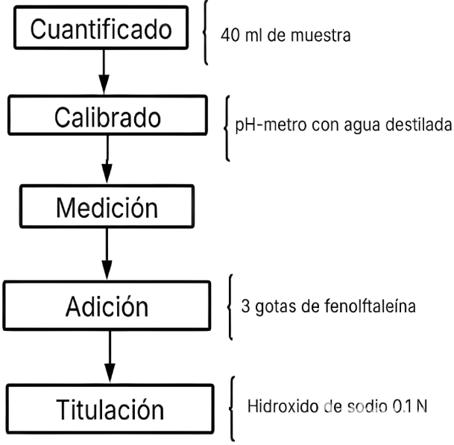

Fig. 1. Flujograma del análisis de pH y acidez

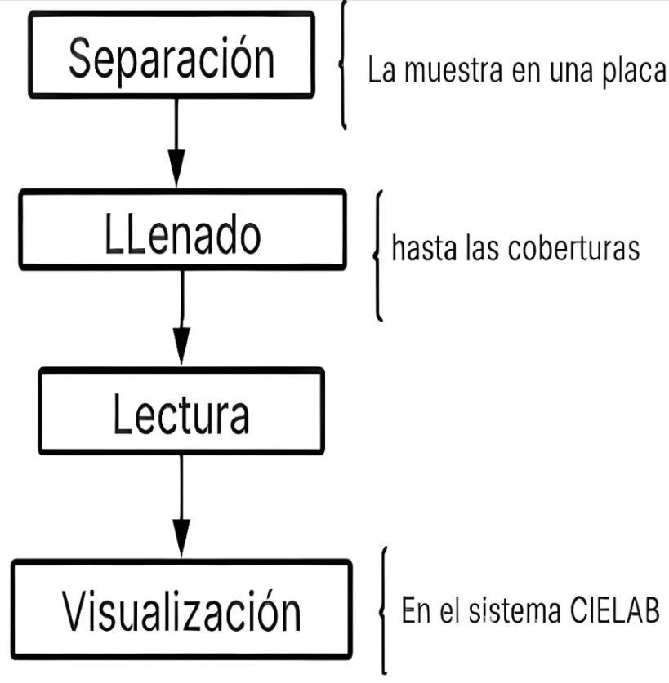

Fig. 2. Flujograma de análisis de colorimetría

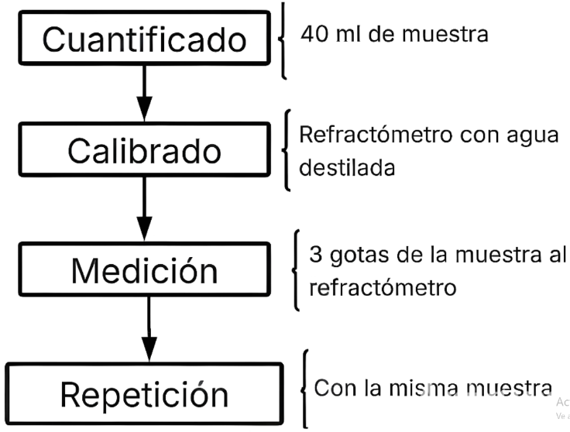

Fig. 3. Flujograma de análisis °brix

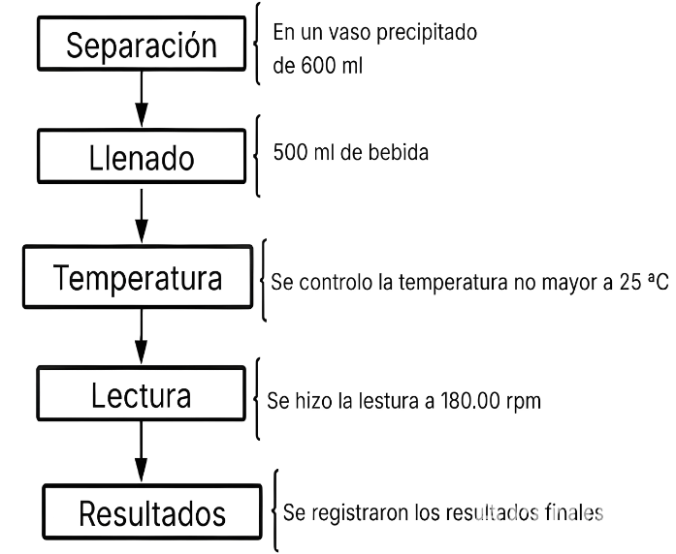

Fig. 4. Flujograma de análisis de viscosidad

Tabla 1. Tabla general de formulaciones

|  |  |  |  |  |  |  |  |  |  |
| --- | --- | --- | --- | --- | --- | --- | --- | --- | --- |
| N | **Nopañ** | **Piña** | **Flor de Jamaica** | **Nop**  **al**  **(%)** | **Piña**  **(%)** | **Flor**  **de**  **Jam**  **aica**  **(%)** | **Nop**  **al**  **(g)** | **Piña**  **(g)** | **Flor**  **de**  **Jama**  **ica**  **(g)** |
| **1** | -1 | -1 | -1 | 5 | 15 | 1.0 | 50 | 150 | 10 |
| **2** | 1 | -1 | -1 | 10 | 15 | 1.0 | 100 | 150 | 10 |
| **3** | -1 | 1 | -1 | 5 | 20 | 1.0 | 50 | 200 | 10 |
| **4** | 1 | 1 | -1 | 10 | 20 | 1.0 | 100 | 200 | 10 |
| **5** | -1 | -1 | 1 | 5 | 15 | 1.5 | 50 | 150 | 15 |
| **6** | 1 | -1 | 1 | 10 | 15 | 1.5 | 100 | 150 | 15 |
| **7** | -1 | 1 | 1 | 5 | 20 | 1.5 | 50 | 200 | 15 |
| **8** | 1 | 1 | 1 | 10 | 20 | 1.5 | 100 | 200 | 15 |
| **9** | 0 | 0 | 0 | 7.5 | 17.5 | 1.3 | 75 | 175 | 13 |
| **10** | 0 | 0 | 0 | 12.5 | 17.5 | 1.3 | 125 | 175 | 13 |
| **11** | 0 | 0 | 0 | 7.5 | 22.5 | 1.3 | 75 | 225 | 13 |
| **12** | 0 | 0 | 0 | 12.5 | 22.5 | 1.3 | 125 | 225 | 13 |

Tabla 2: Resultados del análisis de antocianinas

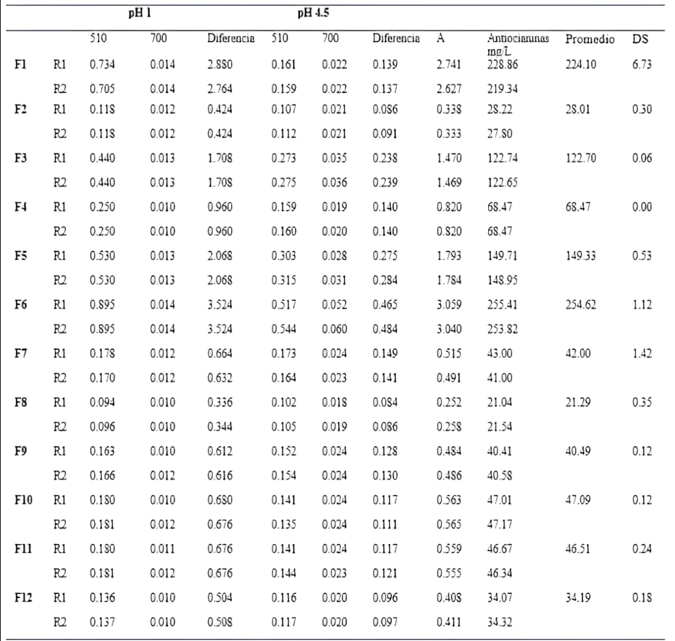

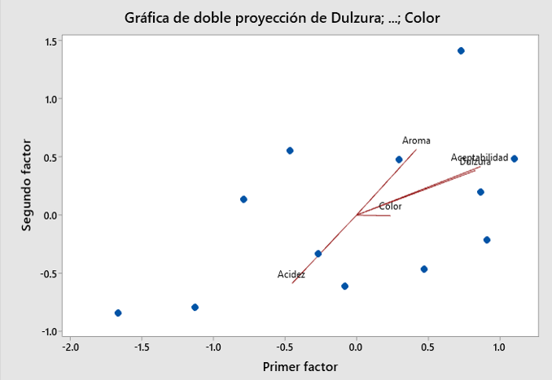

Fig. 5. Gráfica de proyección de los parámetros sensoriales

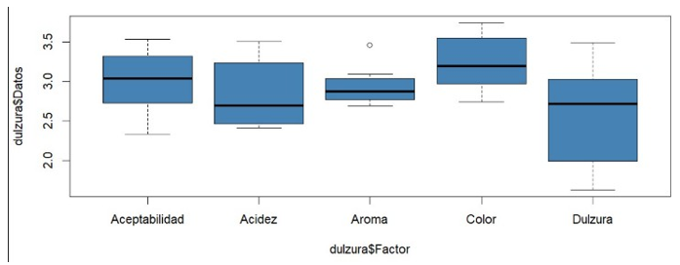

Fig. 6. Diagrama de cajas de los parámetros sensoriales